Decisions of the Speaker-General
Re Plural Form of Sergeant-Major, Hyphenation, and Regimental Sergeant-Major [2024] SpkGenDec 5
Decision of: | The Speaker-General
Date of decision: | 14 August 2024
Catchwords: | English—plural form—where a dispute exists as to the plural form of sergeant-major—United Kingdom uses sergeant-majors—United States uses sergeants-major—question as to whether sergeant-major should be hyphenated—question as to whether non-regimental units should have a regimental sergeant-major.
Number of paragraphs: | 17

DECISION
DECISION MADE BY: THE SPEAKER-GENERAL
DATE OF DECISION: 14 August 2024
THE SPEAKER-GENERAL DECIDES THAT:
- The plural of sergeant-major should be sergeants-major.
- In the question of if sergeant-major should be hyphenated:
  - Rank: Yes
  - Position: Yes
- There should not be a regimental sergeant-major for military units which are not regiments.

REASONS FOR DECISION
THE SPEAKER-GENERAL

Introduction
- I received letter that asked me to determine three questions all relating to the term of “sergeant-major”.
- Firstly, should the plural form of sergeant-major be “sergeants-major” or “sergeant-majors”?
- Secondly, should sergeant-major be hyphenated for (a) the rank or (b) the position?
- Finally, should there be a regimental sergeant-major for military units which are not regiments?
- I shall determine the question on hyphenation first.

Hyphenation of sergeant-major
- Hyphenation of military ranks is inconsistent within the British Government. The websites of all three branches of the British Armed Forces do not use hyphens except for Air Vice-Marshal (Royal Navy, n.d.; British Army, n.d.; Royal Air Force, n.d.). However in notices published in the London Gazette as recent as 14 May 2024, Vice-Admiral is hyphenated (UK Ministry of Defence, 2024).
- The Government Digital Service’s A to Z Style Guide has no guidance on the hyphenation of military ranks (Government Digital Service, 2024). This is a contrast to the Australian Government Style Manual that specifies that the only rank that should be hyphenated is Air Vice-Marshal in the Royal Australian Air Force (Australian Government, 2023). The Australian Government Style Manual in this case is also inconsistent as it does not state that Vice-Admiral should be hyphenated even though both ranks use the word “vice”.
- Now, onto the hyphenation of sergeant-major. Sergeant-major seems to be no longer hyphenated in the London Gazette (London Gazette, 2024). In older gazettals, sergeant-major was hyphenated (Privy Council Office, 1981). The sergeant-major that is mentioned in the Privy Council’s 1981 gazette notice is the Regimental Sergeant-Major, Royal Marines which is an instance of sergeant-major as a position.
- From the research conducted, it would appear that no contemporary sources (within the last 30 years) hyphenate sergeant-major whether it be a position or a rank. Positions such as attorney-general, inspector-general, solicitor-general, auditor-general are positions that I recommend should be hyphenated everywhere even if some countries do not hyphenate those positions. As the majority of general officer ranks such as lieutenant general, major general, colonel general, brigadier general, etc are not hyphenated by a lot of countries.
- I decide that in order to reduce possible confusion, all ranks and position titles that use post-positive adjective should be hyphenated including the general officer ranks mentioned above as it has been in the past even if it goes against the style adopted by most countries. For the same reason, sergeant-major should be hyphenated in instances where it is a rank or a position. I will not make a determination on the plural form of the general officer ranks in this decision.

Plural form of sergeant-major
- There are many sources that use either “sergeants-major” and or “sergeant-majors”. British sources use the latter plural (Privy Council Office, 1981) and American sources use the former plural (United States Marine Corps, n.d.).
- Contemporary dictionaries contain both plural forms (Encyclopædia Britannica, Inc., n.d.-b; Merriam-Webster, n.d.-b; Wiktionary Contributors, 2024).
- The Wikipedia article for sergeant-major states that the origin of the said term is Spanish, specifically from the rank sargento mayor, however the section under the heading of “History” does not feature any references (Wikipedia Contributors, 2024b). There is a link to the page “Sargento mayor”. That page does not feature many references at all. The first reference appears under the third heading (Wikipedia Contributors, 2024a). The reference is a paper that covers the history of military ranks presumably from a Spanish perspective (Toyos, 2010). The paper by Toyos itself has no references but it is still a sign that the origin of sergeant-major is Spanish. Most adjectives in Spanish and other Romance languages are post-positive adjectives which means the adjective is placed after the noun (Mackenzie, n.d.). This means that sargento is the noun and mayor is the adjective. It would make sense for the plural to be sargentos mayor but it isn’t—at least in Spanish. The plural is sargentos mayores (Real Academia Española, n.d.). The same dictionary entry also states the equivalent of a sergeant-general exists but that is beside the point. Both DeepL and Google Translate translates sargentos mayores as sergeants-major, see below. Unfortunately, I was unable to get someone fluent in Spanish and English to provide an authoritative translation so I have to rely on two of the leading online translation tools.
Google Translate
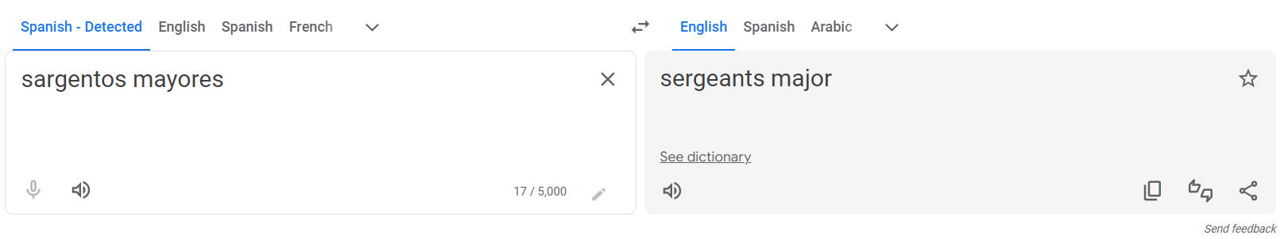
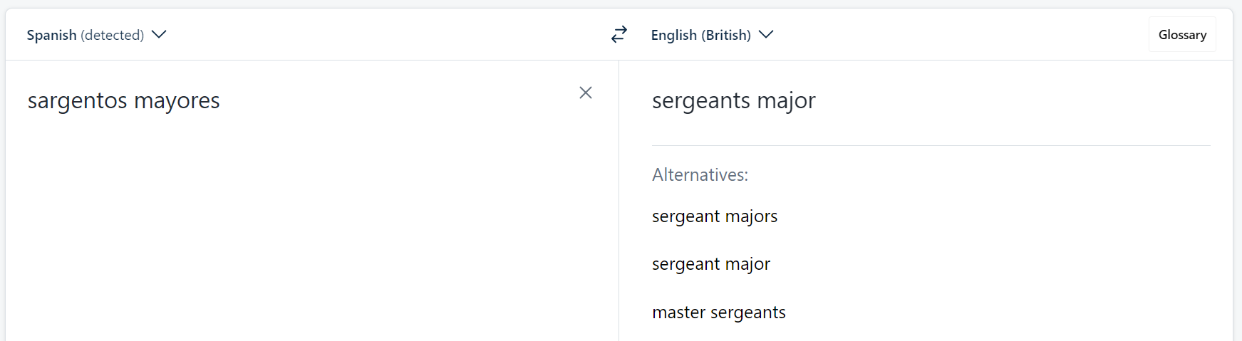
DeepL

- I therefore conclude that the plural of sergeant-major should be sergeants-major.
- During the research for this decision, I found a very small article regarding the origin on of the rank Major General (Sergeant-Major General, 1940).

Regimental Sergeant-Major for Non-Regimental Units?
- In the question of if there should be a regimental sergeant-major for military units which are not regiments. The answer should be very clear. The very definition of “regimental” means in relation to a regiment (Cambridge University Press, n.d.; Dictionary.com, n.d.; Encyclopædia Britannica, Inc., n.d.-a; Merriam-Webster, n.d.-a). The answer is quick and simple.
- No.
I certify that the preceding seventeen (17) numbered paragraphs are a true copy of the reasons for decision of the Honourable the Speaker-General.
Signature:
Date:

References
Australian Government. (2023). Style manual: Australian Defence Force. https://www.stylemanual.gov.au/grammar-punctuation-and-conventions/titles-honours-forms-address/australian-defence-force
British Army. (n.d.). Ranks. UK Ministry of Defence. https://www.army.mod.uk/who-we-are/our-people/ranks/
Cambridge University Press. (n.d.). Regimental. In Cambridge English Dictionary. Retrieved 8 August 2024, from https://dictionary.cambridge.org/dictionary/english/regimental
Dictionary.com (n.d.). Regimental. In Dictionary.com dictionary. Retrieved 8 August, 2024, from https://www.dictionary.com/browse/regimental
Encyclopædia Britannica. (n.d.-a) Regimental. In The Britannica Dictionary. Retrieved 8 August, 2024, from https://www.britannica.com/dictionary/regimental
Encyclopædia Britannica. (n.d.-b) Sergeant Major. In The Britannica Dictionary. Retrieved 8 August, 2024, from https://www.britannica.com/dictionary/regimental
Government Digital Service. (2024). A to Z style guide. HM Government. https://www.gov.uk/guidance/style-guide/a-to-z-of-gov-uk-style
London Gazette. (2024). Appointment of sheriffs. The Stationary Office. https://www.thegazette.co.uk/notice/4597187
Mackenzie, Ian. (n.d.). Adjective placement in Spanish. Newcastle University. Retrieved 10 August 2024, from https://www.staff.ncl.ac.uk/i.e.mackenzie/adjplac.htm
Merriam-Webster. (n.d.-a). Regimental. In Merriam-Webster.com dictionary. Retrieved 8 August, 2024, from https://www.merriam-webster.com/dictionary/regimental
Merriam-Webster. (n.d.-b). Sergeant Major. In Merriam-Webster.com dictionary. Retrieved 8 August, 2024, from https://www.merriam-webster.com/dictionary/sergeant-major
Privy Council Office. (1981). Supplement: 48587 page: 5671. The London Gazette. https://www.thegazette.co.uk/London/issue/48587/supplement/5671
UK Ministry of Defence. (2024). Supplement: 64395 page: 9338. The London Gazette. https://www.thegazette.co.uk/London/issue/64395/supplement/9338
United States Marine Corps. (n.d.). Ranks. https://www.marines.mil/Ranks/
Real Academia Española. (n.d.). Sargento. In Real Academia Española diccionario de la lengua española [Royal Spanish Academy dictionary of the Spanish language]. Retrieved 10 August 2024 from https://dle.rae.es/sargento
Royal Air Force. (n.d.). RAF ranks. United Kingdom Ministry of Defence. https://www.raf.mod.uk/our-organisation/raf-ranks/
Royal Navy. (n.d.). Shaping your career. United Kingdom Ministry of Defence. https://www.royalnavy.mod.uk/careers/life-in-the-navy/shaping-your-career
Sergeant-Major General. (1940, February 9). Nambour Chronicle and North Coast Advertiser (Qld. : 1922–1954), p. 9. http://nla.gov.au/nla.news-article78036387
Toyos, S. (2010). Historia de los grados militares [History of military ranks]. Soldados Digital. https://web.archive.org/web/20150924103618/http://www.soldadosdigital.com/2010/pdf/grados-militares.pdf
Wikipedia contributors. (2024a, June 3). Sargento mayor. Wikipedia. https://en.wikipedia.org/wiki/Sargento_mayor
Wikipedia Contributors. (2024b, July 8). Sergeant major. Wikipedia. https://en.wikipedia.org/w/index.php?title=Sergeant_major&oldid=1233311338
Wiktionary Contributors. (2024, March 9). Sergeant Major. In Wiktionary. https://en.wiktionary.org/w/index.php?title=sergeant_major&oldid=78417368

